The Assignment
A Novel by Liza Wiemer
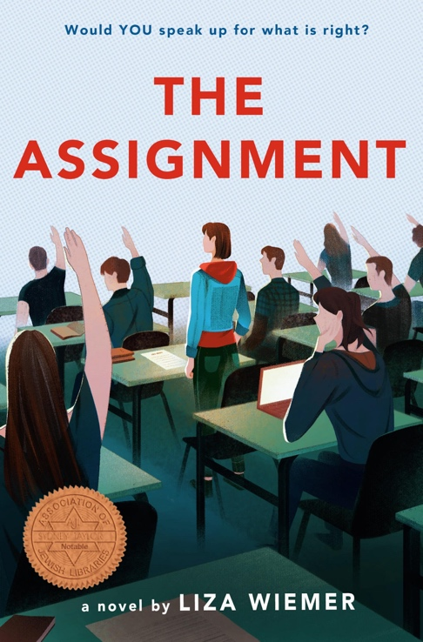
The Assignment was published by Delacorte Press, a division of Penguin Random House, on August 25, 2020. Audiobook by Listening Library. Paperback will be published on August 31, 2021.

To date, foreign rights have sold in Italian, Russian, Polish, and Korean.

About The Assignment:

In the vein of the classic The Wave and inspired by a real-life incident, this riveting novel explores discrimination and antisemitism and reveals their dangerous impact.

Senior Year. When an assignment given by a favorite teacher instructs a group of students to argue for the Final Solution, a euphemism used to describe the Nazi plan for the genocide of the Jewish people, Logan March and Cade Crawford are horrified. Their teacher cannot seriously expect anyone to complete an assignment that fuels intolerance and discrimination. Logan and Cade decide they must take a stand.
As the school administration addresses the teens' refusal to participate in the appalling debate, the student body, their parents, and the larger community are forced to face the issue as well. The situation explodes, and acrimony and anger result. What does it take for tolerance, justice, and love to prevail?

Honors for The Assignment:

- 2022 Sakura Medal nominee (Japan)
- 2022 TAYSHAS nominee (Texas Library Association)
- 2021 American Jewish Libraries Sydney Taylor Notable Book Award for Young Adults
- 2021 Young Adult Library Services Association / American Library Association Best Fiction Novel for Young Adults nominee
- 2021 Milwaukee County Best Teen Honor Book
- 2020 Nerdy Book Club Winner for Young Adult Fiction
- 2020 Australian Labor Party named The Assignment one of their "Progressive Books to Inspire Little Ones and Young People"

Selected Reviews and Interviews:

Amazon

Goodreads

“A Teacher Made His Students Debate Hitler’s Final Solution. What Happened Next was Incredible.” - Reprinted in the Jerusalem Post, Times of Israel, JTA, The Jewish World and more

“Tenafly wasn’t the first to get the Holocaust wrong. Here’s how schools can do better.” NewJersey.com

We Need Diverse Books - Interview (The premier website for bringing diversity into children’s literature)

Entertainment Weekly - Mention by New York Times Best Selling Author, Marissa Meyer

Jewish Book Council - Review

"The Assignment explores what happens when a classroom lesson becomes indefensible” - Wisconsin State Journal

Nerdy Book Club - Review (one of the most prestigious educator websites for book reviews with over 145,000 subscribers)

Praise:

“A good choice for fans of Angie Thomas’s The Hate U Give and Nic Stone’s Dear Martin.”
—School Library Journal

“One of the most interesting, powerful books I’ve read dealing with academic freedom. My bet is that spontaneous discussion will erupt after students read it."
—Pat Scales, the former chair of ALA’s Intellectual Freedom Committee, School Library Journal’s author of Freedom to Read, Covid-19 Edition, Scales on Censorship

“Wise and nuanced.”
—Thanhhà Lại, New York Times bestselling author and National Book Award winner of Inside Out & Back Again and Butterfly Yellow

“A riveting, important, and thought-provoking read. Unputdownable and unforgettable.”
—Leah Cypess, author of The Death Sworn series

“This fast-paced, compelling story will inspire readers to stick to their principles and fight for what’s right. A timely and necessary read.”
—Kip Wilson, author of White Rose

“Brave, breath-stealing and bold. A compelling and necessary read.”
—Gae Polisner, author of The Memory of Things and Jack Kerouac Is Dead to Me

“Riveting, completely realistic, and powerful. Readers won’t be able to resist putting themselves in the students’ shoes and thinking about when and where they themselves would draw the line, or if they would dare confront power at all.”
—Nancy Werlin, New York Times bestselling author and National Book Award Finalist for The Rules of Survival

“. . . this fast paced novel will keep readers thoroughly engaged. An important plot-driven story about two teens who stand up for what’s right in the face of adversity.”
—Kirkus Reviews
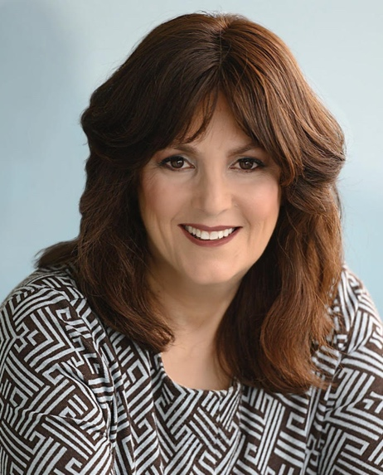

About Liza Wiemer:
Liza Wiemer is an award-winning educator with over twenty years of teaching experience. Her second young adult novel, The Assignment, published by Delacorte Press, Penguin Random House, has received multiple honors, including the Sydney Taylor Notable Award. In addition, Liza has published two adult nonfiction books, another young adult novel, and several short stories included in the New York Times bestselling Small Miracles series. A graduate of UW-Madison, Liza has two married sons and lives in Milwaukee, Wisconsin with her husband, Jim. Website, Twitter, Instagram, Facebook

